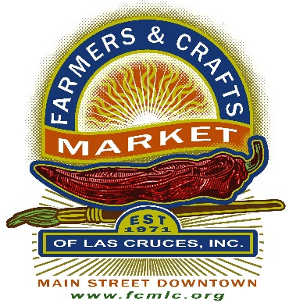

FARMERS AND CRAFTS MARKET OF LAS CRUCES, INC

P. O. BOX 16467

LAS CRUCES, NM 88004

I, _______________________________ of __________________________________ claim that my

(Vendor Name) (Business Name)

business qualifies for an exemption from the rule of providing a current City of Las Cruces Business Registration.

I certify that my business falls under one of the following exemptions:

1. “Sec. 16-128. – Exemptions - (5) A part-time artist whose prior year proceeds from the sale of their artwork through consignment with other licensed businesses does not exceed $1,000.00.”
2. My business is not located within the City of Las Cruces.
3. My business is exempt from filing CRS.

I understand that this is self-reported, and proof may be required should the City of Las Cruces request an audit.

______________________________ ___________________  
Vendor Signature Date