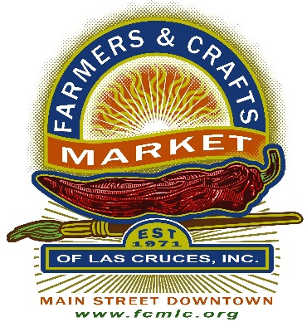

FARMERS AND CRAFTS MARKET OF LAS CRUCES, INC

P. O. BOX 16467

LAS CRUCES, NM 88004

**EXEMPT FROM FILING BTIN IN COMPLIANCE CERTIFICATE STATEMENT**

I, ________________________________________ of ____________________________________

(Print Vendor Name) (Print Business Name)

Certify that I sell only (circle all that apply): Produce Meat Eggs Honey

at Farmers and Crafts Market of Las Cruces, therefore I am exempt from filing BTIN Gross Receipts Tax.

______________________________________ ______________________________________

(Vendor Signature) (Date)