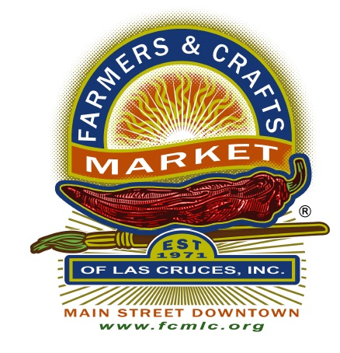 |  | Farmers & Crafts Market of Las Cruces  Board Meeting Agenda (B)  January 9, 2024  6:00 PM- 7:30 PM
Item # | Item
A | Call to order
B | Conflict of Interest Inquiry: At the opening of each Board meeting, the Chair shall ask if any member of the Board, Market Staff, or any vendor present has any known conflict of interest with any item on the agenda.  Remind the Board and the Visitors that the meeting is being recorded electronically
C | Privilege of the Floor: The Board Chairman may grant the privilege of the floor to observers at his/her discretion
D | Approval of Agenda
E | New Business  - Motion, Discussion, Vote: Election of Chairman  - Motion, Discussion, Vote: Election of Vice Chairman  - Motion, Discussion, Vote: Election of Secretary  - Motion, Discussion, Vote: Election of Treasurer  - Motion, Discussion, Vote: Day for regular Board Meetings  - Motion, Discussion, Vote: Frequency of Board Meetings
F | Board Comments: Up to one minute per each Board Member
G | Vendor Comments: Up to two minutes per each vendor
H | Next Board Meeting Time & Date: TBA
I | Adjournment
J

