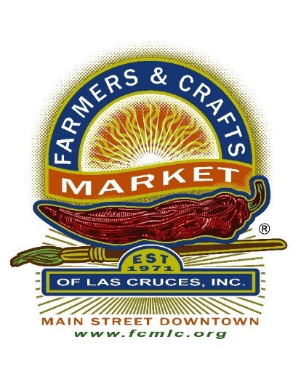

Farmers & Crafts Market of Las Cruces, Inc.

Board Meeting Agenda

M. Phillip’s Gallery Building

221 North Main Street

6:00 – 7:30 PM

February 20, 2024

|  |  |
| --- | --- |
| **#** | **Item** |
| **A** | **Call to Order** |
| **B** | **Conflict of Interest Inquiry** – At the opening of each Board meeting, the Chair shall ask if any member of the Board, Market staff, or any vendor present has any known conflict of interest with any item on the agenda.  Remind the Board and the Visitors that the Meeting is being Recorded Electronically. |
| **C** | **Privilege of the Floor** – The Board Chairman may grant the privilege of the floor to observers at his or her discretion. |
| **D** | **Approval of Agenda** |
| **E** | **Approval of Minutes—**January 9, 2024 |
| **F** | **Committee Reports**  1) Committee Reports:  2) Operations  3) Finance |
| **G** | **Old Business** |
| **H** | **New Business**  1) Motion, Discussion, Vote- Advertising: Bravo Mic Proposal  2) Motion, Discussion, Vote- Advertising: Hutton Broadcasting Proposal  3) Motion, Discussion, Vote-Operations: Easter Egg Hunt Expenses |
| **I** | **Board Comments** (up to 1 minute for each Board member) |
| **J** | **Vendor Comments** (up to 2 minutes per member) |
| **K** | **Next Board Meeting:**  March 19th, 2024. |
| **L** | **Adjournment** |