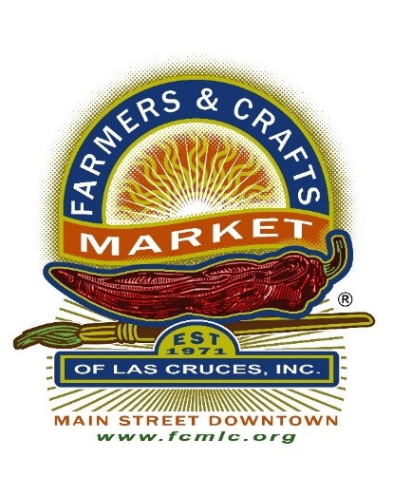

Farmers & Crafts Market of Las Cruces, Inc.

Board Meeting Agenda

Rudy’s BBQ 1020 Telshor Blvd

6:00 – 7:00 PM

March 18, 2025

|  |  |
| --- | --- |
| **#** | **Item** |
| **A** | **Call to Order** |
| **B** | **Conflict of Interest Inquiry** – At the opening of each Board meeting, the Chair shall ask if any member of the Board, Market staff, or any vendor present has any known conflict of interest with any item on the agenda.  Remind the Board and the Visitors that the Meeting is being Recorded Electronically. |
| **C** | **Privilege of the Floor** – The Board Chairman may grant the privilege of the floor to observers at his or her discretion. |
| **D** | **Approval of Agenda** |
| **E** | **Approval of Minutes— February 18, 2025** |
| **F** | **Committee Reports**  1) Operations  2) Finance |
| **G** | **Old Business** |
| **H** | **New Business**   1. Motion, Discussion, Vote- Sponsorship-Mesilla Valley CASA 2. Motion, Discussion, Vote- Gift Bag Inserts-Mesilla Valley Maze 3. Motion, Discussion, Vote-Certified Folder Contract 4. Motion, Discussion, Vote- Southwest Contemporary Business Listing |
| **I** | **Board Comments** (up to 1 minute for each Board member) |
| **J** | **Vendor Comments** (up to 2 minutes per member) |
| **K** | **Next Board Meeting:**  April 15, 2025 |
| **L** | **Adjournment** |