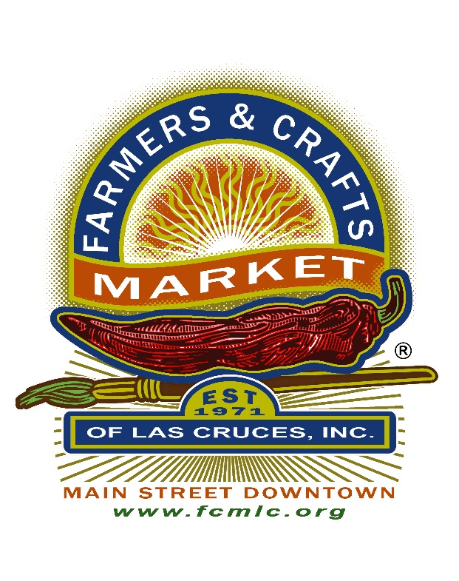
Farmers & Crafts Market of Las Cruces, Inc.
Annual Board Meeting Agenda
NMSU Golf Course Banquet Room
3000 Herb Wimberly Drive
6:00 – 9:00PM
December 6, 2022
# | Item
A | Call to Order
B | Conflict of Interest Inquiry – At the opening of each Board meeting, the Chair shall ask if any member of the Board, Market staff, or any vendor present has any known conflict of interest with any item on the agenda.  Remind the Board and the Visitors that the Meeting is being Recorded Electronically.
C | Privilege of the Floor – The Board Chairman may grant the privilege of the floor to observers at his or her discretion.
D | Approval of Agenda
E | Approval of Minutes- 9/13, 10/11, 11/8, 11/15
F | Committee Reports  - Operations
G | New Business  - Election Results  - State of the Market Report  - Motion, Discussion, Vote- 2023 FCMLC Annual Budget
H | Board Comments (up to 1 minute for each Board member)
I | Vendor Comments (up to 2 minutes per member)
J | Next Board Meeting January 10, 2023  Time- 6:00 – 7:30 PM
K | Adjournment
L

